Instructions on how to run the code:
Question 1: the function can be found in HomogenousTransform.m and can be visualized in HTransformDemo.m. To see the transform, run HTransformDemo.m.
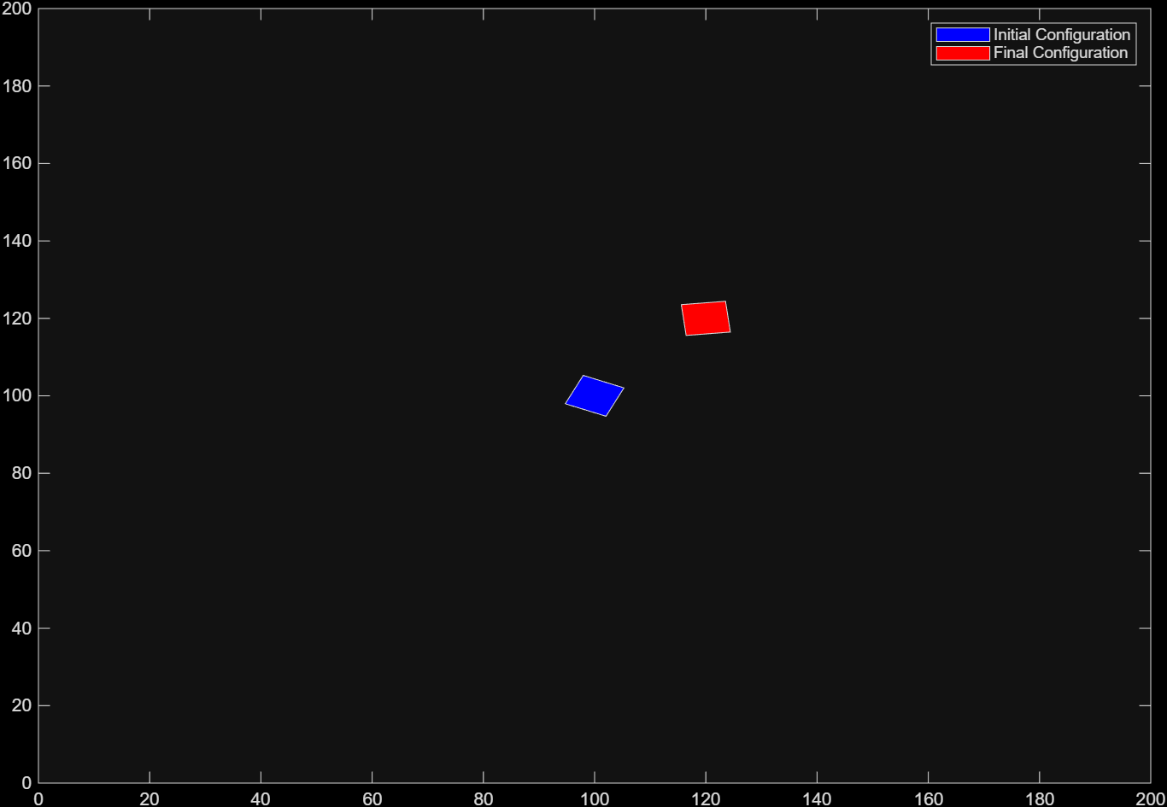
Question 2: This question can be visualized by running the goToGoal.m file.
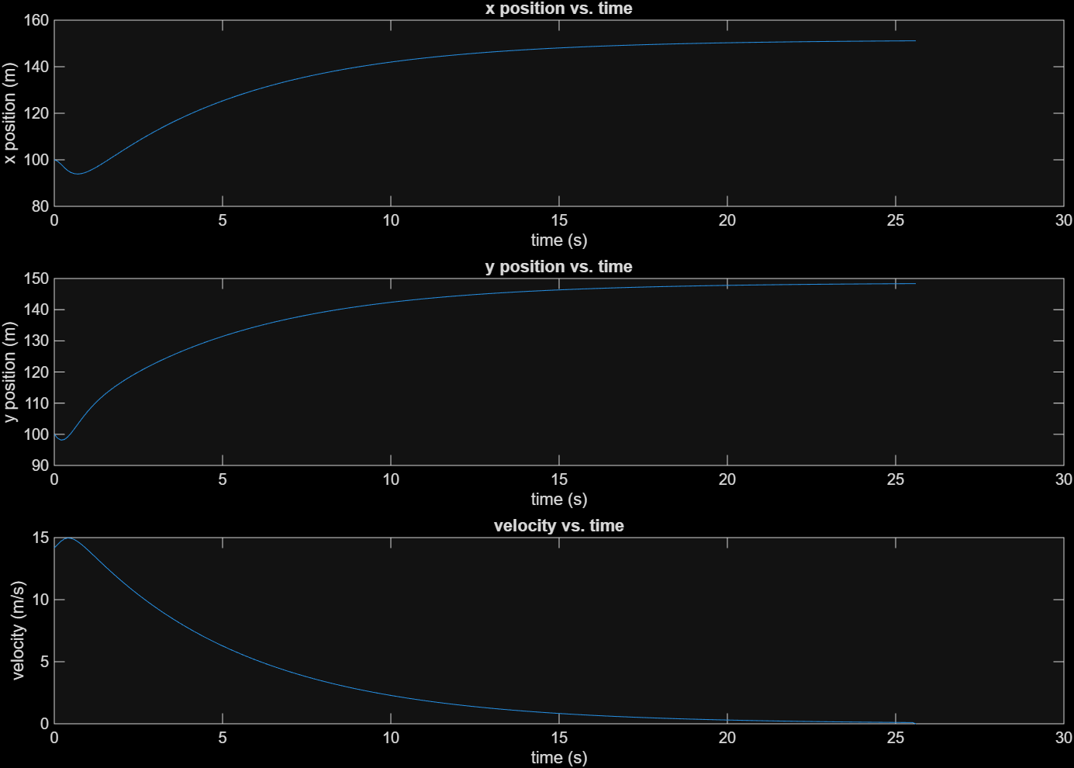
Question 3: This question can be visualized by running CruiseControl.m.
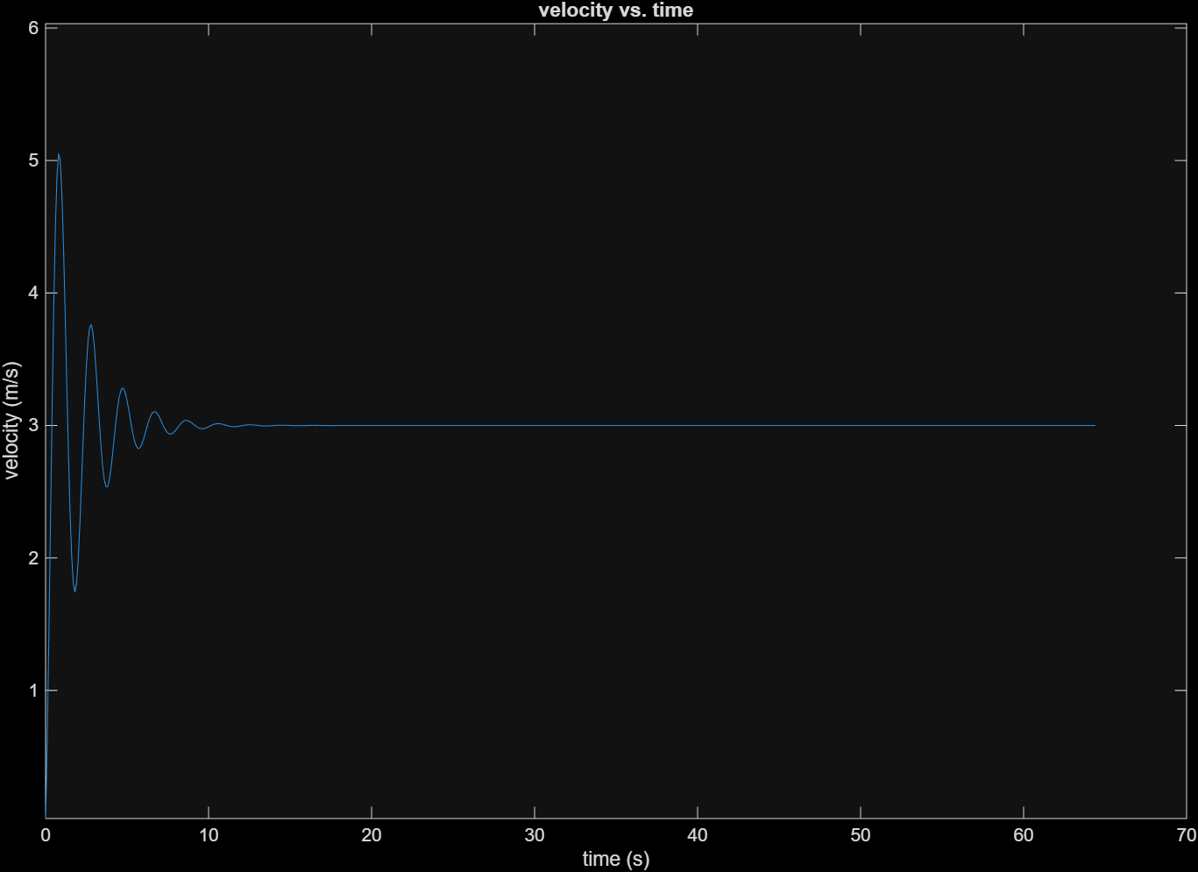
Question 4: This code can be visualized by running FollowWall.m.
